COURSE: Database Fundamentals (DBF510S)

LAB 1: Database Environment

Due date: Friday 27th February 2025 before 12h00 mid-night
______________________________________________________________________________ In this lab you will learn :
- How to self-enrol on elearning and access MS Teams
PART 1- Self enrol on elearning
PART 2- Access MS Teams
- The 3 database environments used in this course:
PART A -Microsoft Access
PART B- Microsoft SQL Management Studio PART C- Sqlite

PART 1- Enrolment
All DBF510S students will be enrolled by the coordinator once the students are registered for the course. Students who are not enrolled should email schivuno@nust.na

PART 2- Access MS Teams
- Theory classes will be conducted on Mondays at 15hrs in Auditorium 1 (Full-time), Tuesdays at 18:40hrs in Auditorium 2 (Part-time), and Thursdays at 07:30hrs and 14hrs in Auditorium 1(Full-time ) .

- There might be situations where MS Teams will be used for Theory classes, but you will be informed by the class representatives or through announcements on E-learning. Follow the defined steps to access the Database Fundamentals Team.
Note that we have added all students to the Team, which means Database Fundamentals appears as one of your teams. If you do not have access, you

Click on the Join MS Teams link on Elearning

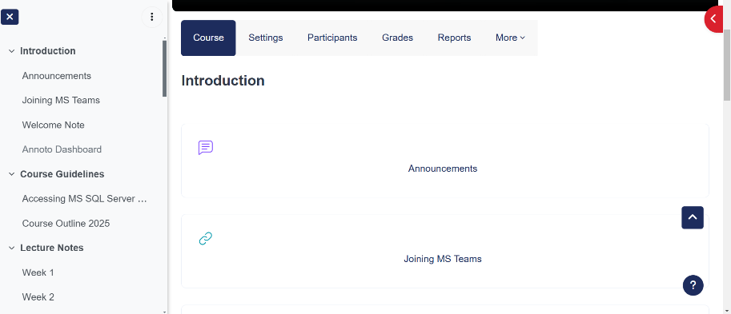

Select Teams, and identify Database Fundamentals from the list of your teams.

Then you can follow the class proceedings.
- Navigate the environment to identify where you find the posted lecture slides and other documents.
- Navigate the environment to identify where you can find class recordings.

PART-A –How to practice with Microsoft Access
By the end of PART-A, you should be familiar with:
• Some basic features of MS Access, navigation pane, ribbon, status bar, using online database templates

Instruction
Choose one of the following three ways to open the Northwind 2007 or higher database:
- Open MS Access; click Sample under the category listed in the left task pane on the Getting Started with Office Access page; then click on the Northwind 2007 icon, enter the name and location on the right task pane and click the Download button.
Or
- Go to directory C:\ProgramFiles\Microsoft
Office\Templates\1033\Access\ and double click Northwind.accdb.
Or
- Open MS Access, Select New, type Northwind on the search field, double click to open Northwind database.
After the Northwind 2007 or higher is launched as shown below please answer the following questions in a note pad file named “surname student#”.
Note: the Northwind sample database in an older version of MS Access is very
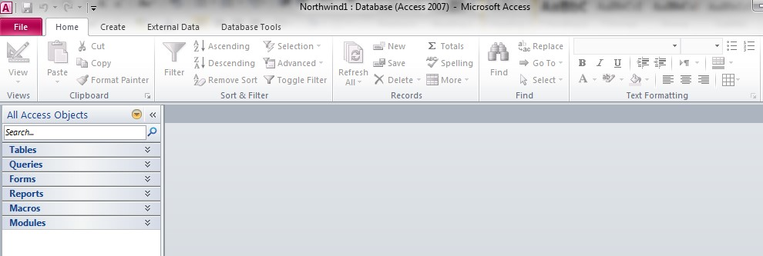
different from the one in MS Access 2007 or higher )
What version of Access do you have?
- Choose Object Type on the Navigation Pane. Please list different objects or components available in the Northwind Database window? Describe any FIVE of them in simple words in terms of their functions (include references to the source of your information).

- In the TABLE Shippers, how many shippers are there? Please list them.

- Create a new database in Microsoft Access named with your student No, and within that database, create two tables:
Customers Table with the fields: CustomerID (Primary Key), FirstName, LastName, Email
Orders Table with the fields: OrderID (Primary Key), OrderDate, CustomerID (Foreign Key), OrderAmount
Create the Customers Table:
  - In the "Table Design" view, create the following fields:
    - CustomerID (Primary Key) – Set as AutoNumber to auto-generate unique customer IDs.
    - FirstName – Set as Short Text.
    - LastName – Set as Short Text.
    - Email – Set as Short Text.
  - Save the table as "Customers."
- Create the Orders Table:
  - In the "Table Design" view, create the following fields:
    - OrderID (Primary Key) – Set as AutoNumber.
    - OrderDate – Set as Date/Time.
    - CustomerID (Foreign Key) – Set as Number (to reference the CustomerID in the Customers table).
    - OrderAmount – Set as Currency.
  - Save the table as "Orders."
- Populate the Tables:
  - Open the "Customers" table and add sample data for at least 4 customers (for example):
    - CustomerID = 1, FirstName = John, LastName = Doe, Email = john.doe@example.com
    - CustomerID = 2, FirstName = Jane, LastName = Smith, Email = jane.smith@example.com
    - CustomerID = 3, FirstName = Mike, LastName = Johnson, Email = mike.johnson@example.com
    - Insert your details as customer 4.
  - Open the "Orders" table and add sample data:
    - OrderID = 1, OrderDate = 2025-02-10, CustomerID = 1, OrderAmount = 150.00
    - OrderID = 2, OrderDate = 2025-02-12, CustomerID = 2, OrderAmount = 75.50
    - OrderID = 3, OrderDate = 2025-02-13, CustomerID = 3, OrderAmount = 250.00
    - OrderID = 4, OrderDate = 2025-02-14, CustomerID = 1, OrderAmount = 180.25
Save your work on your Nust One drive with the assistance of your practical lecturer!
______________________________________________________________________________

PART B: Microsoft SQL Management Studio
By the end of PART-B, you should be familiar with:
• Some basic features of Microsoft SQL Management Studio • Standard terminology

Getting and Understanding your Tools
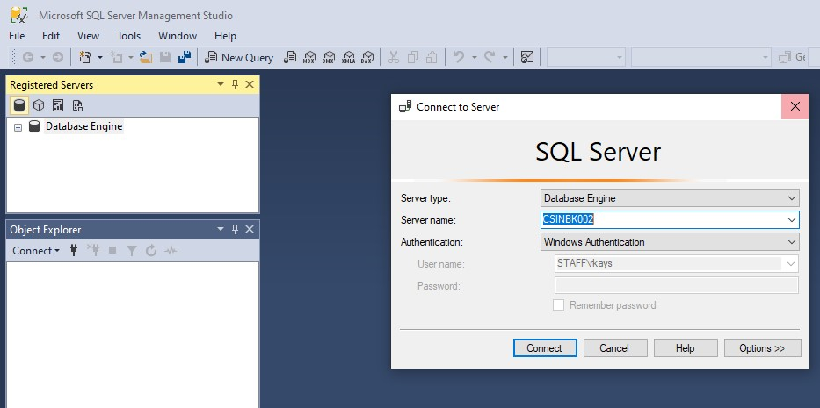

- On the taskbar, click Start, point to All Programs, point to Microsoft SQL Server Tools, and then click SQL Server Management Studio. The Connect to Server window is displayed.
- Login to the SQL Server Management Studio with the corresponding credentials.
(Select Server name) TCP:172.20.253.110
- Click Connect
- With the help of your practical instructor explore other available feature and options in your Microsoft SQL environment e.g. open a new query window, execute a query, saving a script, creating a new database, connect and disconnecting the SQL server.

PART C: Accessing SQLite
Follow the following instructions to access sqliteonline
- Ensure that you have an internet connection and launch your browser e.g. Chrome, Mozilla Firefox, Microsoft Edge
- Type www.sqliteonline.com on the address bar
- The sqlite environment is displayed
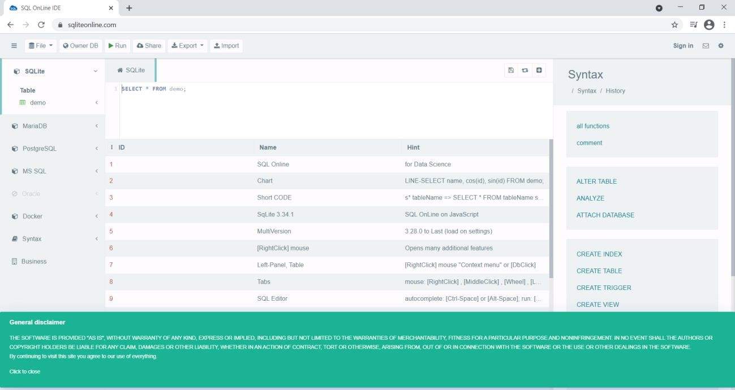
- Identify the following important features:
- Navigation pane - lists all database objects,
ii. Execute command,
- Save command ,
iv. Import command,
v. Export command,
vi. Workspace - where you type your SQL statements,
vii. Any other feature that you have identified.

Lab Report: All lab reports need to be submitted as it may contribute towards your final mark.
Only PART A work should be submitted. The note pad document with your Surname_Student # and upload on to ELearning platform (Moodle/ ENust). The Microsoft Access Databases with work from Q. 1-6 should also be submitted.
____________________________________________________________________________________

As a reminder: Plagiarized and late reports will be marked with zero. ~END~

